PROJECT REPORT: SHOPPER SPECTRUM

1. Project Introduction
The Shopper Spectrum project focuses on understanding customer purchasing behavior in an e-commerce environment and using that understanding to support business decisions.
Modern e-commerce platforms collect massive transaction data, but raw data alone does not provide value. This project transforms that raw data into:
- Meaningful customer segments
- Personalized product recommendations
The project has two main goals:
- Customer Segmentation – Identify different types of customers based on behavior
- Product Recommendation – Suggest similar products based on past purchases

2. Dataset Understanding (Jupyter Notebook)
The dataset used is an online retail transaction dataset.
Each row represents one product purchased in a transaction.
Important columns explained:
- InvoiceNo – Transaction/bill number
- StockCode – Product identifier
- Description – Product name
- Quantity – Units purchased
- InvoiceDate – Date and time of purchase
- UnitPrice – Price per unit
- CustomerID – Unique customer identifier
- Country – Customer’s location
This dataset allows us to answer:
- Who bought what?
- How often do they buy?
- How much do they spend?

3. Data Cleaning & Pre-processing
Real-world data is noisy, so cleaning is essential.
Steps performed:
3.1 Removing missing CustomerID
Transactions without a customer ID cannot be linked to a customer, so they are removed.
Reason: Customer-level analysis is impossible without identification.

3.2 Removing cancelled invoices
Invoices starting with “C” indicate cancellations.
Reason: Cancelled orders do not represent actual purchases and distort spending behavior.

3.3 Removing invalid values
Transactions with:
- Zero or negative quantity
- Zero or negative price
are removed.
Reason: These represent returns or data errors and mislead revenue analysis.

3.4 Creating TotalPrice
A new feature is created:
TotalPrice = Quantity × UnitPrice
Reason: This represents the actual revenue generated per transaction and is essential for customer value analysis.

4. Exploratory Data Analysis (EDA)
EDA is kept minimal and business-focused (UBM style).
Key insights obtained:
- Which countries generate most transactions
- How sales change over time
- Which products contribute most to revenue
Purpose:
To understand overall business patterns before modeling.

5. Feature Engineering – RFM Analysis
Raw transactions are converted into customer behavior features using RFM analysis.
5.1 Recency
Number of days since a customer’s last purchase.
Business meaning:
Recent customers are more engaged.

5.2 Frequency
Number of purchases made by a customer.
Business meaning:
Frequent buyers are loyal customers.

5.3 Monetary
Total amount spent by a customer.
Business meaning:
High spenders are more valuable.

Why RFM?
RFM provides a compact but powerful summary of customer behavior and is widely used in real businesses.

6. Handling Outliers
Extreme values exist, especially in:
- Frequency
- Monetary
Instead of removing these customers, Winsorization is used.
Winsorization
Caps extreme values at the 99th percentile.
Why used:
- Reduces distortion in clustering
- Retains valuable high-spending customers

7. Data Transformation
Additional behavior-based features are created:
- Monetary per Transaction
- Recency to Frequency Ratio
Purpose:
To capture deeper behavioral patterns beyond basic RFM values.

8. Data Scaling
The QuantileTransformer is used to scale features.
Why this method:
- Converts skewed data into a normal distribution
- Reduces impact of outliers
- Improves distance-based clustering performance

9. Customer Segmentation Model (K-Means)
Model Used: K-Means Clustering
K-Means groups customers based on similarity in their scaled RFM features.
Why K-Means:
- No predefined labels (unsupervised)
- Simple and interpretable
- Widely used in industry

Cluster Selection
- Elbow Method – Chooses optimal cluster count
- Silhouette Score – Validates cluster separation
The final model achieved a Silhouette Score of 0.3632, indicating meaningful clusters.

10. Customer Segment Interpretation
Clusters are labeled based on average RFM values:
High-Value Customers
- Recent
- Frequent
- High spenders
Business action: Loyalty programs, VIP offers

Regular Customers
- Moderate behavior
Business action: Upselling and engagement

Occasional Customers
- Low frequency and spending
Business action: Discounts and incentives

At-Risk Customers
- Long time since last purchase
Business action: Win-back campaigns

11. Product Recommendation System
Model Used: Item-Based Collaborative Filtering
This model recommends products based on co-purchase behavior.
Core idea:
If many customers buy Product A and Product B together, they are similar.

How it works:
- Create a customer–product interaction matrix
- Calculate similarity using cosine similarity
- Recommend top similar products

Business impact:
- Improves cross-selling
- Increases average order value
- Enhances customer experience

12. Model Evaluation
Customer Segmentation
- Evaluated using Silhouette Score
- Confirms clusters are meaningful and not random
Product Recommendation
- Evaluated qualitatively
- Ensures recommended products are logically similar

13. Streamlit Web Application
The Streamlit app makes the project usable in real life.

Home Page
Introduces the application and its features.
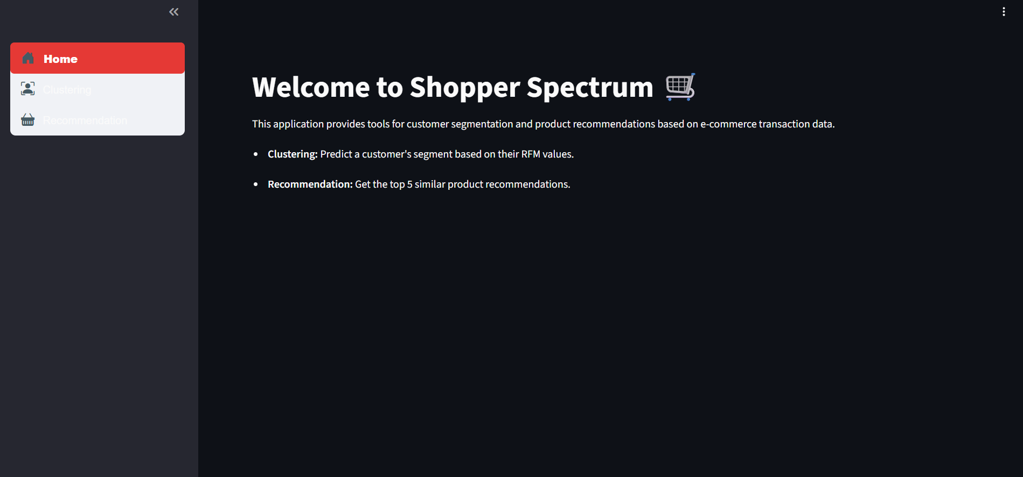

Customer Segmentation Page
User inputs:
- Recency
- Frequency
- Monetary
The app:
- Scales the input
- Predicts the cluster
- Maps it to a business-friendly segment label
Example:
“At-Risk Shopper” → customer likely to churn

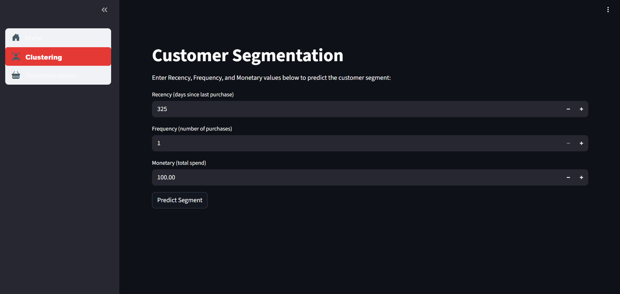

Product Recommendation Page
User enters a product name.
The app:
- Finds similar products using purchase similarity
- Displays top 5 recommendations
Example:
Entering GREEN VINTAGE SPOT BEAKER
Returns similar vintage-style products.
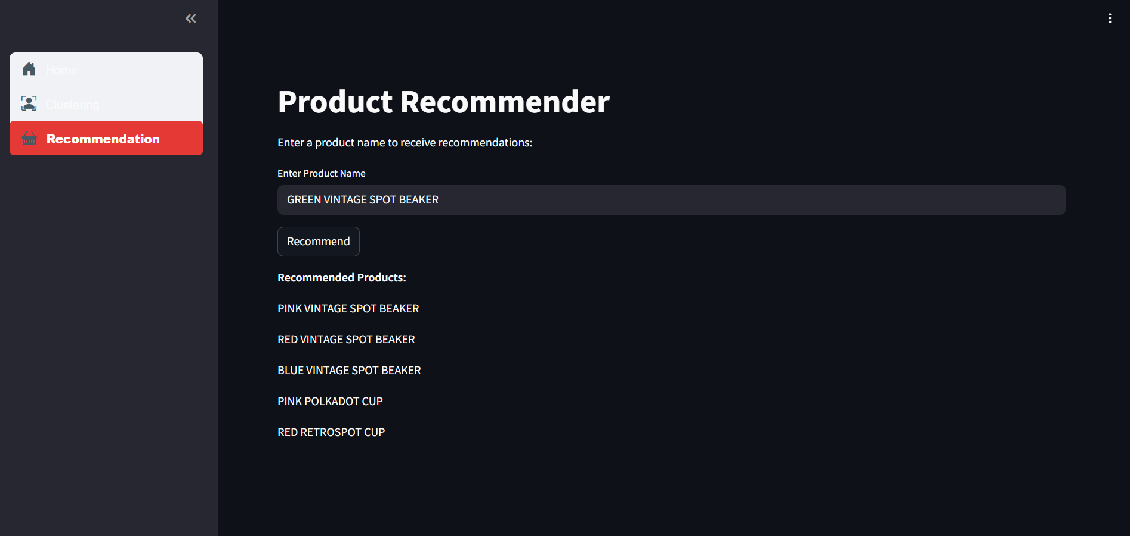

14. Network URL
The Shopper Spectrum application is deployed as a web-based Streamlit app and can be accessed through a network URL.
Local Access (Development):http://localhost:8501
Network URL: http://10.147.200.212:8501
Description:
When the Streamlit server is running, this URL opens the web interface in a browser. Users can interact with the application to perform customer segmentation and receive product recommendations in real time.
Purpose:
Provides a simple web interface for demonstrating and testing the end-to-end machine learning solution.

15. Final Conclusion
This project successfully:
- Converts raw transaction data into insights
- Segments customers meaningfully
- Provides personalized product recommendations
- Deploys models using an interactive web app
It demonstrates end-to-end data science skills, from data cleaning and modeling to deployment and business interpretation.
This project segments customers using RFM-based clustering and recommends similar products using collaborative filtering, enabling data-driven personalization in e-commerce.

